Ideation Phase
Empathize & Discover

Date | 03 February 2026
Team ID | LTVIP2026TMIDS88090
Project Name | AUTOSAGE APP USING GEMINI FLASH
Maximum Marks | 4 Marks

Empathy Map Canvas:
The user is an urban Indian vehicle buyer or vehicle owner who is trying to make an informed decision about purchasing or evaluating a vehicle but feels overwhelmed due to scattered, biased, and inconsistent information available online. The user thinks about long-term ownership cost, resale value, mileage, reliability, and whether choosing ICE or EV is the right decision. The user sees confusing comparisons, aggressive dealership marketing, influencer promotions, and varying price quotes across platforms. The user hears mixed advice from friends, sales executives, social media, and automotive news regarding fuel prices, EV adoption, and brand reputation. The user says and does things like searching “best car under ₹10 lakh,” comparing mileage figures, checking reviews, visiting showrooms, and asking for recommendations but still feels uncertain. The user experiences pain due to information overload, lack of structured analysis, fear of financial mistakes, and uncertainty about hidden maintenance or resale risks. The user ultimately seeks clarity, structured intelligence, transparent cost insights, and confidence in decision-making — which AUTOSAGE APP USING GEMINI FLASH aims to provide.
Example:
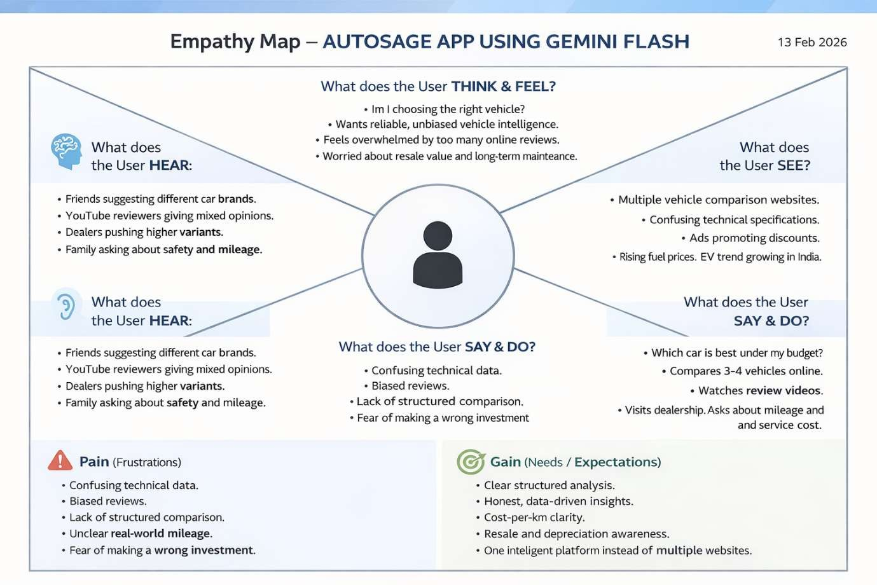

Reference: https://www.mural.co/templates/empathy-map-canvas

Example: AI Vehicle Intelligence & Advisory Application
